22K-5195 WE-LAB-9 BSE-6B
1)
using Microsoft.AspNetCore.Mvc;
using Microsoft.EntityFrameworkCore;
using System;
using System.Threading.Tasks;
using System.Collections.Generic;
using we_lab_9.Data;
using we_lab_9.Models;

namespace we_lab_9.Controllers
{
public class StudentController : Controller
{
private readonly ApplicationDbContext dbContext;

public StudentController(ApplicationDbContext context)
{
dbContext = context;
}

[HttpGet]
public async Task<IActionResult> GetStudentsJson()
{
var students = await dbContext.students.ToListAsync();
return Json(students);
}

[HttpPost]
public async Task<IActionResult> AddStudentAjax([FromBody] AddStudentViewModel viewModel)
{
if (!ModelState.IsValid)
{
return Json(new { success = false, message = "Invalid data." });
}

var student = new student
{
Id = Guid.NewGuid(),
Name = viewModel.Name,
Email = viewModel.Email,
Phone = viewModel.Phone,
Subscribed = viewModel.Subscribed
};

await dbContext.students.AddAsync(student);
await dbContext.SaveChangesAsync();

return Json(new { success = true, message = "Student added successfully" });
}

[HttpPost]
public async Task<IActionResult> EditStudentAjax([FromBody] student updatedStudent)
{
var student = await dbContext.students.FindAsync(updatedStudent.Id);
if (student == null)
{
return Json(new { success = false, message = "Student not found" });
}

student.Name = updatedStudent.Name;
student.Email = updatedStudent.Email;
student.Phone = updatedStudent.Phone;
student.Subscribed = updatedStudent.Subscribed;

await dbContext.SaveChangesAsync();
return Json(new { success = true, message = "Student updated successfully" });
}

[HttpPost]
public async Task<IActionResult> DeleteStudentAjax([FromBody] Guid id)
{
var student = await dbContext.students.FindAsync(id);
if (student == null)
{
return Json(new { success = false, message = "Student not found" });
}

dbContext.students.Remove(student);
await dbContext.SaveChangesAsync();
return Json(new { success = true, message = "Student deleted successfully" });
}

public IActionResult Add() => View();
public IActionResult List() => View();
}
}

using Microsoft.AspNetCore.Identity.EntityFrameworkCore;
using Microsoft.EntityFrameworkCore;
using we_lab_9.Models;

namespace we_lab_9.Data
{
public class ApplicationDbContext : IdentityDbContext
{
public ApplicationDbContext(DbContextOptions<ApplicationDbContext> options)
: base(options)
{
}

public DbSet<student> students { get; set; }
}
}

namespace we_lab_9.Models
{
public class AddStudentViewModel
{
public string Name { get; set; }
public string Email { get; set; }
public string Phone { get; set; }
public bool Subscribed { get; set; }
}
}

using System;

namespace we_lab_9.Models
{
public class student
{
public Guid Id { get; set; }
public string Name { get; set; }
public string Email { get; set; }
public string Phone { get; set; }
public bool Subscribed { get; set; }
}
}

@{
ViewData["Title"] = "Add Student";
}

<h2>Add Student (AJAX)</h2>

<form id="addStudentForm">
<div>
<label>Name:</label>
<input type="text" id="Name" required />
</div>
<div>
<label>Email:</label>
<input type="email" id="Email" required />
</div>
<div>
<label>Phone:</label>
<input type="text" id="Phone" required />
</div>
<div>
<label>
<input type="checkbox" id="Subscribed" /> Subscribed
</label>
</div>
<div>
<button type="submit">Add Student</button>
</div>
</form>

@section Scripts {
<script src="https://code.jquery.com/jquery-3.6.0.min.js"></script>
<script>
$(document).ready(function () {
$('#addStudentForm').submit(function (e) {
e.preventDefault();

const student = {
Name: $('#Name').val(),
Email: $('#Email').val(),
Phone: $('#Phone').val(),
Subscribed: $('#Subscribed').is(":checked")
};

$.ajax({
url: '/Student/AddStudentAjax',
type: 'POST',
contentType: 'application/json',
data: JSON.stringify(student),
success: function (response) {
alert(response.message);
$('#addStudentForm')[0].reset();
},
error: function () {
alert('Error adding student');
}
});
});
});
</script>
}

@{
ViewData["Title"] = "Student List";
}

<h2>Student List (AJAX)</h2>

<table class="table" id="studentTable">
<thead>
<tr>
<th>Name</th>
<th>Email</th>
<th>Phone</th>
<th>Subscribed</th>
<th>Actions</th>
</tr>
</thead>
<tbody>
</tbody>
</table>

<div id="editModal" style="display:none; background:#f0f0f0; padding:20px;">
<h3>Edit Student</h3>
<input type="hidden" id="editId" />
<input type="text" id="editName" placeholder="Name" required />
<input type="email" id="editEmail" placeholder="Email" required />
<input type="text" id="editPhone" placeholder="Phone" required />
<label>
<input type="checkbox" id="editSubscribed" /> Subscribed
</label>
<button onclick="submitEdit()">Update</button>
<button onclick="$('#editModal').hide()">Cancel</button>
</div>

@section Scripts {
<script src="https://code.jquery.com/jquery-3.6.0.min.js"></script>
<script>
function loadStudents() {
$.ajax({
url: '/Student/GetStudentsJson',
type: 'GET',
success: function (data) {
const tbody = $('#studentTable tbody');
tbody.empty();
data.forEach(function (student) {
tbody.append(`
<tr>
<td>${student.name}</td>
<td>${student.email}</td>
<td>${student.phone}</td>
<td>${student.subscribed}</td>
<td>
<button onclick="editStudent('${student.id}', '${student.name}', '${student.email}', '${student.phone}', ${student.subscribed})">Edit</button>
<button onclick="deleteStudent('${student.id}')">Delete</button>
</td>
</tr>`);
});
},
error: function () {
alert('Error fetching data');
}
});
}

function editStudent(id, name, email, phone, subscribed) {
$('#editId').val(id);
$('#editName').val(name);
$('#editEmail').val(email);
$('#editPhone').val(phone);
$('#editSubscribed').prop('checked', subscribed);
$('#editModal').show();
}

function submitEdit() {
const student = {
Id: $('#editId').val(),
Name: $('#editName').val(),
Email: $('#editEmail').val(),
Phone: $('#editPhone').val(),
Subscribed: $('#editSubscribed').is(':checked')
};

$.ajax({
url: '/Student/EditStudentAjax',
type: 'POST',
contentType: 'application/json',
data: JSON.stringify(student),
success: function (response) {
alert(response.message);
$('#editModal').hide();
loadStudents();
},
error: function () {
alert('Error updating student');
}
});
}

function deleteStudent(id) {
if (!confirm("Are you sure you want to delete this student?")) return;

$.ajax({
url: '/Student/DeleteStudentAjax',
type: 'POST',
contentType: 'application/json',
data: JSON.stringify(id),
success: function (response) {
alert(response.message);
loadStudents();
},
error: function () {
alert('Error deleting student');
}
});
}

$(document).ready(function () {
loadStudents();
});
</script>
}

<!DOCTYPE html>
<html lang="en">
<head>
<meta charset="utf-8" />
<meta name="viewport" content="width=device-width, initial-scale=1.0" />
<title>@ViewData["Title"] - we_lab_9</title>
<link rel="stylesheet" href="~/lib/bootstrap/dist/css/bootstrap.min.css" />
<link rel="stylesheet" href="~/css/site.css" asp-append-version="true" />
<link rel="stylesheet" href="~/we_lab_9.styles.css" asp-append-version="true" />
</head>
<body>
<div class="container">
<nav>
<ul>
<li><a asp-controller="Student" asp-action="Add">Add Student</a></li>
<li><a asp-controller="Student" asp-action="List">List Students</a></li>
</ul>
</nav>

@RenderBody()
</div>

@RenderSection("Scripts", required: false)
</body>
</html>


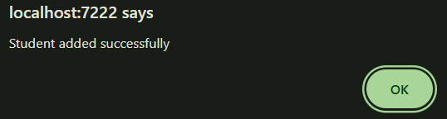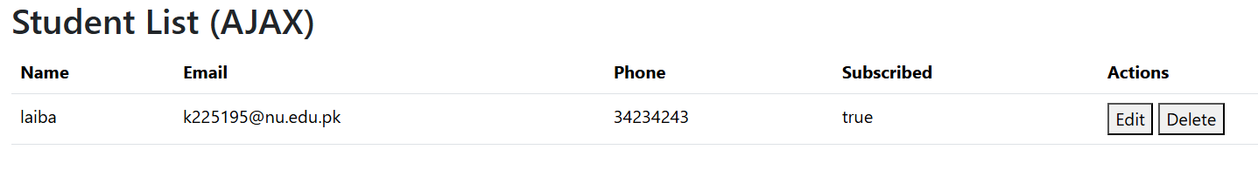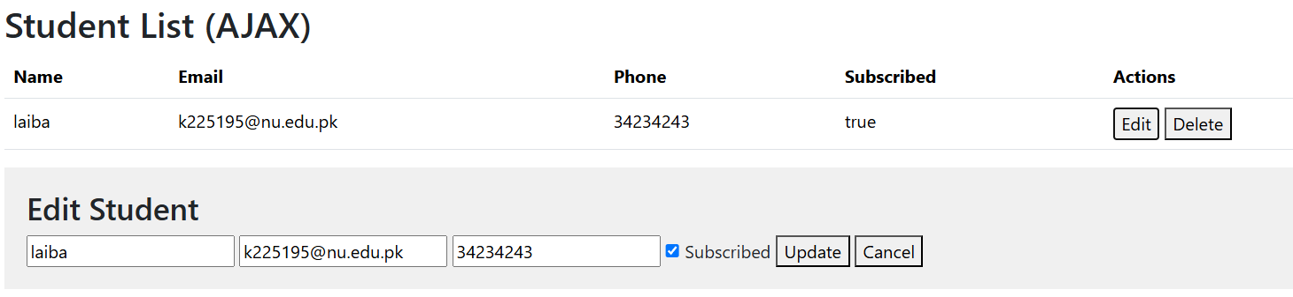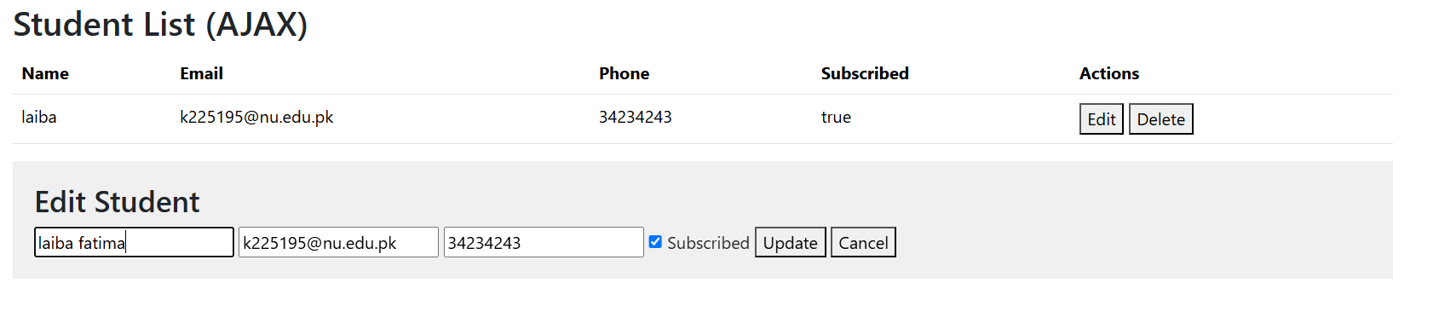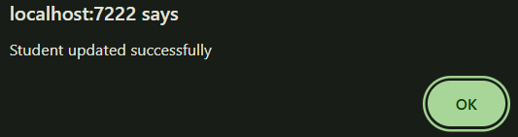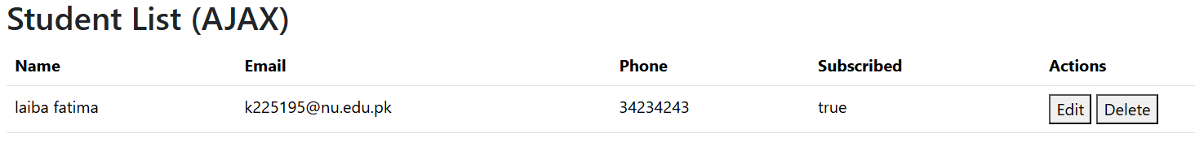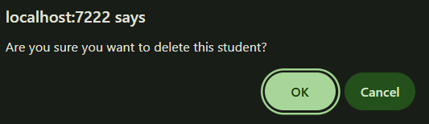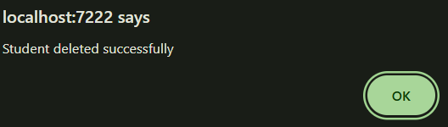
2)
using Microsoft.AspNetCore.Mvc;
using Microsoft.EntityFrameworkCore;
using we_lab_9.Data;
using we_lab_9.Models;

public class PatientController : Controller
{
private readonly ApplicationDbContext _context;

public PatientController(ApplicationDbContext context)
{
_context = context;
}

// GET: Patient
public async Task<IActionResult> Index()
{
var patients = await _context.Patients.ToListAsync();
return View(patients);
}

// GET: Patient/Details/5
public async Task<IActionResult> Details(int? id)
{
if (id == null)
return NotFound();

var patient = await _context.Patients.FirstOrDefaultAsync(m => m.Id == id);
if (patient == null)
return NotFound();

return View(patient);
}

// GET: Patient/Create
public IActionResult Create()
{
return View();
}

// POST: Patient/Create
[HttpPost]
[ValidateAntiForgeryToken]
public async Task<IActionResult> Create([Bind("Name,Age,Gender,Phone,Address")] Patient patient)
{
if (ModelState.IsValid)
{
_context.Add(patient);
await _context.SaveChangesAsync();
return RedirectToAction(nameof(Index));
}
return View(patient);
}

// GET: Patient/Edit/5
public async Task<IActionResult> Edit(int? id)
{
if (id == null)
return NotFound();

var patient = await _context.Patients.FindAsync(id);
if (patient == null)
return NotFound();

return View(patient);
}

// POST: Patient/Edit/5
[HttpPost]
[ValidateAntiForgeryToken]
public async Task<IActionResult> Edit(int id, [Bind("Id,Name,Age,Gender,Phone,Address")] Patient patient)
{
if (id != patient.Id)
return NotFound();

if (ModelState.IsValid)
{
try
{
_context.Update(patient);
await _context.SaveChangesAsync();
}
catch (DbUpdateConcurrencyException)
{
if (!PatientExists(patient.Id))
return NotFound();
else
throw;
}
return RedirectToAction(nameof(Index));
}
return View(patient);
}

// GET: Patient/Delete/5
public async Task<IActionResult> Delete(int? id)
{
if (id == null)
return NotFound();

var patient = await _context.Patients.FirstOrDefaultAsync(m => m.Id == id);
if (patient == null)
return NotFound();

return View(patient);
}

// POST: Patient/Delete/5
[HttpPost, ActionName("Delete")]
[ValidateAntiForgeryToken]
public async Task<IActionResult> DeleteConfirmed(int id)
{
var patient = await _context.Patients.FindAsync(id);
_context.Patients.Remove(patient);
await _context.SaveChangesAsync();
return RedirectToAction(nameof(Index));
}

private bool PatientExists(int id)
{
return _context.Patients.Any(e => e.Id == id);
}
}
using System.ComponentModel.DataAnnotations;

namespace we_lab_9.Models
{
public class Patient
{
public int Id { get; set; }

[Required]
public string Name { get; set; }

public int Age { get; set; }

public string Gender { get; set; }

public string Phone { get; set; }

public string Address { get; set; }
}
}

@model we_lab_9.Models.Patient

@{
ViewData["Title"] = "Add New Patient";
}

<h2>Add New Patient</h2>

<form asp-action="Create" method="post" class="mt-3">
<div class="form-group mb-2">
<label asp-for="Name" class="form-label"></label>
<input asp-for="Name" class="form-control" />
<span asp-validation-for="Name" class="text-danger"></span>
</div>

<div class="form-group mb-2">
<label asp-for="Age" class="form-label"></label>
<input asp-for="Age" class="form-control" />
<span asp-validation-for="Age" class="text-danger"></span>
</div>

<div class="form-group mb-2">
<label asp-for="Gender" class="form-label"></label>
<select asp-for="Gender" class="form-control">
<option value="">-- Select Gender --</option>
<option>Male</option>
<option>Female</option>
<option>Other</option>
</select>
<span asp-validation-for="Gender" class="text-danger"></span>
</div>

<div class="form-group mb-2">
<label asp-for="Phone" class="form-label"></label>
<input asp-for="Phone" class="form-control" />
<span asp-validation-for="Phone" class="text-danger"></span>
</div>

<div class="form-group mb-2">
<label asp-for="Address" class="form-label"></label>
<textarea asp-for="Address" class="form-control"></textarea>
<span asp-validation-for="Address" class="text-danger"></span>
</div>

<button type="submit" class="btn btn-primary">Submit</button>
<a asp-action="Index" class="btn btn-secondary">Cancel</a>
</form>

@section Scripts {
<partial name="_ValidationScriptsPartial" />
}
@model we_lab_9.Models.Patient

@{
ViewData["Title"] = "Delete Patient";
}

<h2>Delete Patient</h2>

<h4>Are you sure you want to delete this patient?</h4>
<hr />

<div class="border p-3 mb-3">
<dl class="row">
<dt class="col-sm-2">Name</dt>
<dd class="col-sm-10">@Model.Name</dd>

<dt class="col-sm-2">Age</dt>
<dd class="col-sm-10">@Model.Age</dd>

<dt class="col-sm-2">Gender</dt>
<dd class="col-sm-10">@Model.Gender</dd>

<dt class="col-sm-2">Phone</dt>
<dd class="col-sm-10">@Model.Phone</dd>

<dt class="col-sm-2">Address</dt>
<dd class="col-sm-10">@Model.Address</dd>
</dl>
</div>

<form asp-action="Delete" method="post">
<input type="hidden" asp-for="Id" />
<button type="submit" class="btn btn-danger">Confirm Delete</button>
<a asp-action="Index" class="btn btn-secondary">Cancel</a>
</form>

@model we_lab_9.Models.Patient

@{
ViewData["Title"] = "Patient Details";
}

<h2>Patient Details</h2>
<hr />

<div class="border p-3 mb-3">
<dl class="row">
<dt class="col-sm-2">Name</dt>
<dd class="col-sm-10">@Model.Name</dd>

<dt class="col-sm-2">Age</dt>
<dd class="col-sm-10">@Model.Age</dd>

<dt class="col-sm-2">Gender</dt>
<dd class="col-sm-10">@Model.Gender</dd>

<dt class="col-sm-2">Phone</dt>
<dd class="col-sm-10">@Model.Phone</dd>

<dt class="col-sm-2">Address</dt>
<dd class="col-sm-10">@Model.Address</dd>
</dl>
</div>

<a asp-action="Edit" asp-route-id="@Model.Id" class="btn btn-warning">Edit</a>
<a asp-action="Index" class="btn btn-secondary">Back to List</a>
@model we_lab_9.Models.Patient

@{
ViewData["Title"] = "Edit Patient";
}

<h2>Edit Patient</h2>

<form asp-action="Edit" method="post" class="mt-3">
<input type="hidden" asp-for="Id" />

<div class="form-group mb-2">
<label asp-for="Name" class="form-label"></label>
<input asp-for="Name" class="form-control" />
<span asp-validation-for="Name" class="text-danger"></span>
</div>

<div class="form-group mb-2">
<label asp-for="Age" class="form-label"></label>
<input asp-for="Age" class="form-control" />
<span asp-validation-for="Age" class="text-danger"></span>
</div>

<div class="form-group mb-2">
<label asp-for="Gender" class="form-label"></label>
<select asp-for="Gender" class="form-control">
<option>Male</option>
<option>Female</option>
<option>Other</option>
</select>
<span asp-validation-for="Gender" class="text-danger"></span>
</div>

<div class="form-group mb-2">
<label asp-for="Phone" class="form-label"></label>
<input asp-for="Phone" class="form-control" />
<span asp-validation-for="Phone" class="text-danger"></span>
</div>

<div class="form-group mb-2">
<label asp-for="Address" class="form-label"></label>
<textarea asp-for="Address" class="form-control"></textarea>
<span asp-validation-for="Address" class="text-danger"></span>
</div>

<button type="submit" class="btn btn-success">Save Changes</button>
<a asp-action="Index" class="btn btn-secondary">Cancel</a>
</form>

@section Scripts {
<partial name="_ValidationScriptsPartial" />
}

@model IEnumerable<we_lab_9.Models.Patient>

@{
ViewData["Title"] = "Patient List";
}

<h2>Patient List</h2>

<p>
<a asp-action="Create" class="btn btn-primary">Add New Patient</a>
</p>

<table class="table table-bordered table-striped">
<thead class="table-dark">
<tr>
<th>Name</th>
<th>Age</th>
<th>Gender</th>
<th>Phone</th>
<th>Address</th>
<th>Actions</th>
</tr>
</thead>
<tbody>
@foreach (var patient in Model)
{
<tr>
<td>@patient.Name</td>
<td>@patient.Age</td>
<td>@patient.Gender</td>
<td>@patient.Phone</td>
<td>@patient.Address</td>
<td>
<a asp-action="Edit" asp-route-id="@patient.Id" class="btn btn-sm btn-warning">Edit</a>
<a asp-action="Details" asp-route-id="@patient.Id" class="btn btn-sm btn-info">Details</a>
<a asp-action="Delete" asp-route-id="@patient.Id" class="btn btn-sm btn-danger">Delete</a>
</td>
</tr>
}
</tbody>
</table>

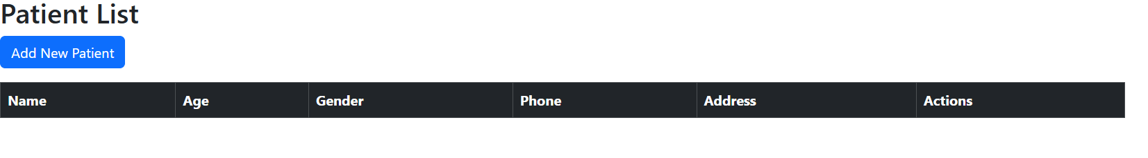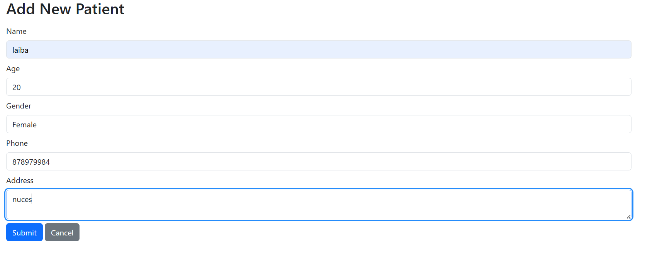
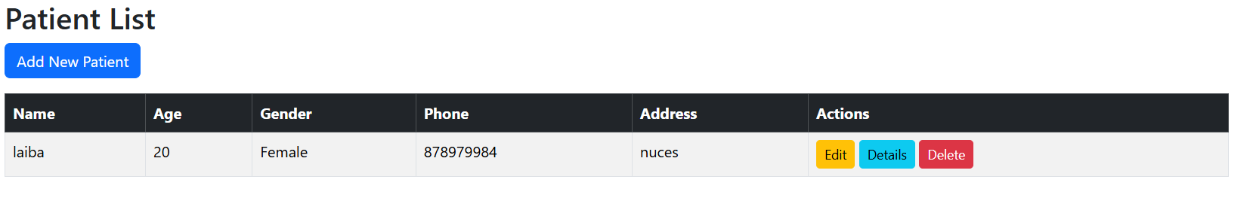
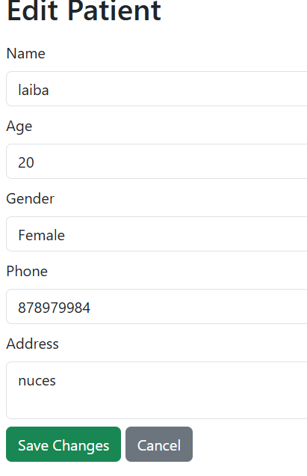
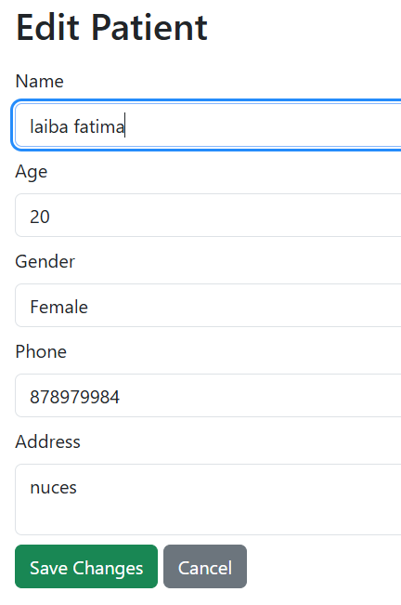
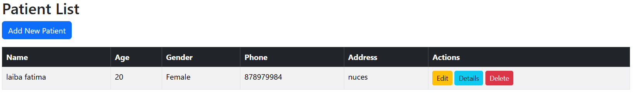
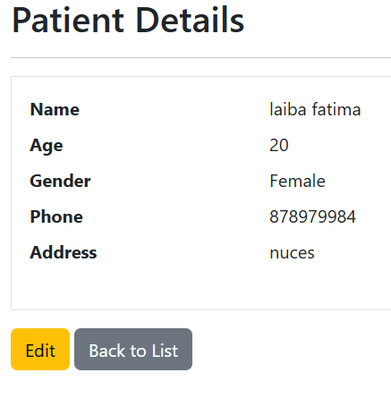
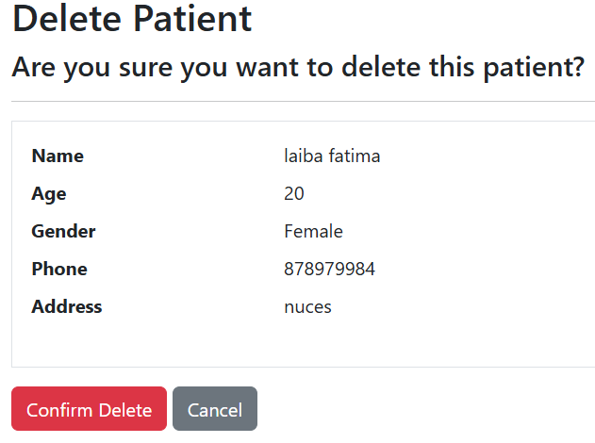
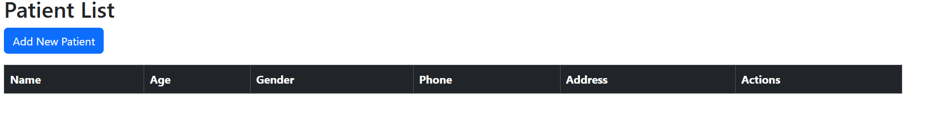

3)
using Microsoft.AspNetCore.Mvc;
using Microsoft.EntityFrameworkCore;
using we_lab_9.Data;
using we_lab_9.Models;
using System.Threading.Tasks;

namespace we_lab_9.Controllers
{
[Route("PatientAjax")]
public class PatientAjaxController : Controller
{
private readonly ApplicationDbContext _context;

public PatientAjaxController(ApplicationDbContext context)
{
_context = context;
}

// GET: PatientAjax/Index
[HttpGet("Index")]
public async Task<IActionResult> Index()
{
var patients = await _context.Patients.ToListAsync();
return View(patients);
}

// GET: PatientAjax/Create
[HttpGet("Create")]
public IActionResult Create()
{
return View();
}

// POST: PatientAjax/Create
[HttpPost("Create")]
public async Task<IActionResult> Create([FromBody] Patient patient)
{
if (ModelState.IsValid)
{
_context.Patients.Add(patient);
await _context.SaveChangesAsync();
return Json(new { success = true, message = "Patient added successfully" });
}
return Json(new { success = false, message = "Error adding patient" });
}

// GET: PatientAjax/Edit/{id}
[HttpGet("Edit/{id}")]
public async Task<IActionResult> Edit(int id)
{
var patient = await _context.Patients.FindAsync(id);
if (patient == null)
{
return NotFound();
}
return View(patient);
}

// POST: PatientAjax/Edit/{id}
[HttpPost("Edit/{id}")]
public async Task<IActionResult> Edit(int id, [FromBody] Patient patient)
{
if (id != patient.Id)
{
return BadRequest();
}

var existingPatient = await _context.Patients.FindAsync(id);
if (existingPatient == null)
{
return NotFound();
}

existingPatient.Name = patient.Name;
existingPatient.Age = patient.Age;
existingPatient.Gender = patient.Gender;
existingPatient.Phone = patient.Phone;
existingPatient.Address = patient.Address;

await _context.SaveChangesAsync();

return Json(new { success = true, message = "Patient updated successfully" });
}

// GET: PatientAjax/Details/{id}
[HttpGet("Details/{id}")]
public async Task<IActionResult> Details(int id)
{
var patient = await _context.Patients.FindAsync(id);
if (patient == null)
{
return NotFound();
}
return View(patient);
}

// POST: PatientAjax/DeletePatient
[HttpPost("DeletePatient")]
public async Task<IActionResult> DeletePatient([FromBody] int patientId)
{
var patient = await _context.Patients.FindAsync(patientId);
if (patient != null)
{
_context.Patients.Remove(patient);
await _context.SaveChangesAsync();
return Json(new { success = true, message = "Patient deleted successfully" });
}
return Json(new { success = false, message = "Patient not found" });
}
}
}

@{
ViewData["Title"] = "Add Patient (AJAX)";
}

<h2>@ViewData["Title"]</h2>

<form id="addPatientForm">
<input type="text" id="Name" placeholder="Name" required />
<input type="number" id="Age" placeholder="Age" required />
<input type="text" id="Gender" placeholder="Gender" required />
<input type="text" id="Phone" placeholder="Phone" required />
<input type="text" id="Address" placeholder="Address" required />
<button type="submit">Add Patient</button>
</form>

@section Scripts {
<script src="https://code.jquery.com/jquery-3.6.0.min.js"></script>
<script>
$(document).ready(function () {
$('#addPatientForm').submit(function (e) {
e.preventDefault();
const patient = {
Name: $('#Name').val(),
Age: parseInt($('#Age').val()),
Gender: $('#Gender').val(),
Phone: $('#Phone').val(),
Address: $('#Address').val()
};

console.log("Sending patient data:", patient);

$.ajax({
url: '/PatientAjax/AddPatient',
type: 'POST',
contentType: 'application/json',
data: JSON.stringify(patient),
success: function (response) {
console.log("Server response:", response);
if (response.success) {
alert(response.message);
window.location.href = '/PatientAjax/Index'; // redirect to patient list
} else {
alert("Failed to add patient: " + response.message);
}
},
error: function (xhr, status, error) {
console.error("Error adding patient:", xhr.responseText);
alert('AJAX Error: ' + xhr.statusText);
}
});
});
});
</script>
}

@{
ViewData["Title"] = "Patient Details (AJAX)";
}

<h2>@ViewData["Title"]</h2>

<table class="table">
<tr>
<th>Name</th>
<td>@Model.Name</td>
</tr>
<tr>
<th>Age</th>
<td>@Model.Age</td>
</tr>
<tr>
<th>Gender</th>
<td>@Model.Gender</td>
</tr>
<tr>
<th>Phone</th>
<td>@Model.Phone</td>
</tr>
<tr>
<th>Address</th>
<td>@Model.Address</td>
</tr>
</table>

<a href="/PatientAjax/Index" class="btn btn-primary">Back to List</a>

@{
ViewData["Title"] = "Edit Patient (AJAX)";
}

<h2>@ViewData["Title"]</h2>

<form id="editPatientForm">
<input type="hidden" id="PatientId" value="@Model.Id" />
<input type="text" id="Name" value="@Model.Name" required />
<input type="number" id="Age" value="@Model.Age" required />
<input type="text" id="Gender" value="@Model.Gender" required />
<input type="text" id="Phone" value="@Model.Phone" required />
<input type="text" id="Address" value="@Model.Address" required />
<button type="submit">Update Patient</button>
</form>

@section Scripts {
<script src="https://code.jquery.com/jquery-3.6.0.min.js"></script>
<script>
$(document).ready(function () {
$('#editPatientForm').submit(function (e) {
e.preventDefault();
const patient = {
Id: $('#PatientId').val(),
Name: $('#Name').val(),
Age: parseInt($('#Age').val()),
Gender: $('#Gender').val(),
Phone: $('#Phone').val(),
Address: $('#Address').val()
};

$.ajax({
url: '/PatientAjax/EditPatient',
type: 'POST',
contentType: 'application/json',
data: JSON.stringify(patient),
success: function (response) {
if (response.success) {
alert(response.message);
window.location.href = '/PatientAjax/Index'; // redirect to patient list
} else {
alert("Failed to update patient: " + response.message);
}
},
error: function (xhr) {
alert('Error editing patient: ' + xhr.statusText);
}
});
});
});
</script>
}

@{
ViewData["Title"] = "Patient List (AJAX)";
}

<h2>@ViewData["Title"]</h2>

<table class="table" id="patientTable">
<thead>
<tr>
<th>Name</th>
<th>Age</th>
<th>Gender</th>
<th>Phone</th>
<th>Address</th>
<th>Actions</th>
</tr>
</thead>
<tbody>
<!-- Patient rows will be added here by JS -->
</tbody>
</table>

@section Scripts {
<script src="https://code.jquery.com/jquery-3.6.0.min.js"></script>
<script>
function loadPatients() {
console.log("Loading patients...");

$.ajax({
url: '/PatientAjax/GetPatients',
type: 'GET',
success: function (data) {
console.log("Received patients:", data);
const tbody = $('#patientTable tbody');
tbody.empty();

data.forEach(function (patient) {
tbody.append(`
<tr>
<td>${patient.Name}</td>
<td>${patient.Age}</td>
<td>${patient.Gender}</td>
<td>${patient.Phone}</td>
<td>${patient.Address}</td>
<td>
<a href="/PatientAjax/Edit/${patient.Id}" class="btn btn-info btn-sm">Edit</a>
<a href="/PatientAjax/Details/${patient.Id}" class="btn btn-success btn-sm">Details</a>
<button class="btn btn-danger btn-sm" onclick="deletePatient(${patient.Id})">Delete</button>
</td>
</tr>
`);
});
},
error: function (xhr, status, error) {
console.error("Error loading patients:", xhr.responseText);
alert('Could not load patients');
}
});
}

function deletePatient(id) {
if (!confirm("Are you sure you want to delete this patient?")) return;

$.ajax({
url: '/PatientAjax/DeletePatient',
type: 'POST',
contentType: 'application/json',
data: JSON.stringify(id),
success: function (response) {
console.log("Delete response:", response);
alert(response.message);
if (response.success) {
loadPatients(); // refresh list
}
},
error: function (xhr) {
console.error("Delete error:", xhr.responseText);
alert("Error deleting patient");
}
});
}

$(document).ready(function () {
loadPatients(); // Initial load when the page is ready
});

function loadPatients() {
console.log("Loading patients...");

$.ajax({
url: '/PatientAjax/Index',
type: 'GET',
success: function (data) {
console.log("Received patients:", data);
const tbody = $('#patientTable tbody');
tbody.empty(); // Clear the table body before appending new rows

// Check if data is an array and contains items
if (Array.isArray(data) && data.length > 0) {
data.forEach(function (patient) {
// Debugging: Log each patient object to confirm we are accessing the correct properties
console.log('Rendering patient:', patient);

// Make sure patient properties are being correctly accessed
tbody.append(`
<tr>
<td>${patient.name || 'N/A'}</td>
<td>${patient.age || 'N/A'}</td>
<td>${patient.gender || 'N/A'}</td>
<td>${patient.phone || 'N/A'}</td>
<td>${patient.address || 'N/A'}</td>
<td>
<a href="/PatientAjax/Edit/${patient.id}" class="btn btn-info btn-sm">Edit</a>
<a href="/PatientAjax/Details/${patient.id}" class="btn btn-success btn-sm">Details</a>
<button class="btn btn-danger btn-sm" onclick="deletePatient(${patient.id})">Delete</button>
</td>
</tr>
`);
});
} else {
console.log("No patients found.");
tbody.append('<tr><td colspan="6">No patients found</td></tr>');
}
},
error: function (xhr, status, error) {
console.error("Error loading patients:", xhr.responseText);
alert('Could not load patients');
}
});
}

</script>
}










